The S3 bucket is created:

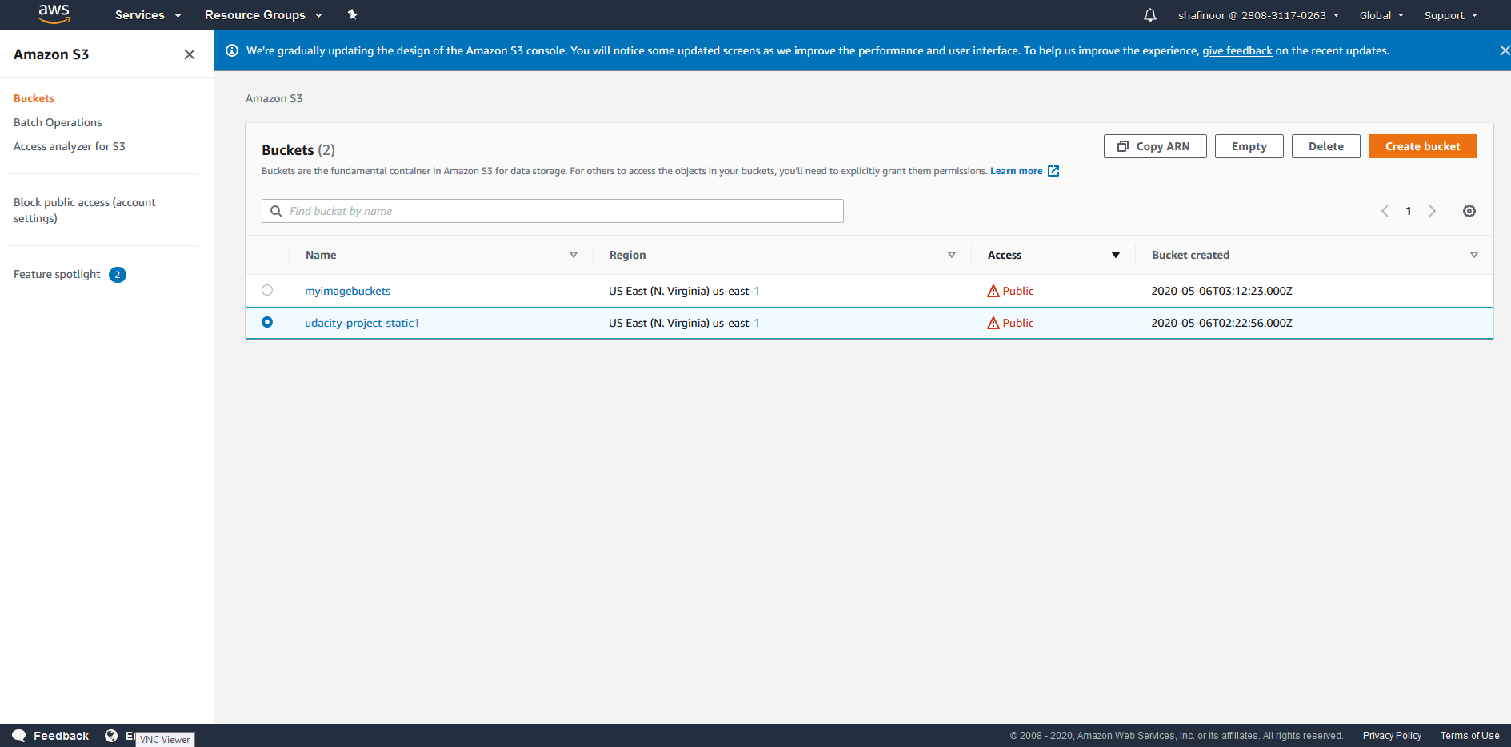

The S3 bucket is configured to support static website hosting:

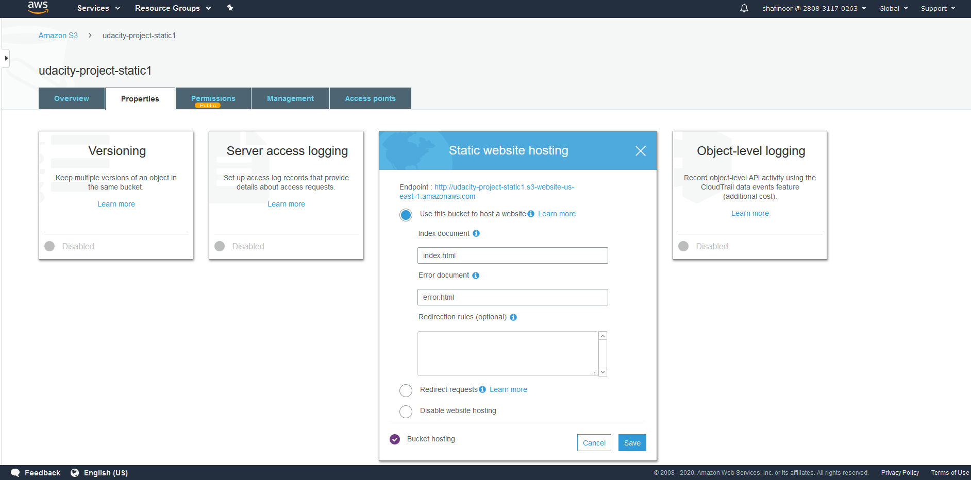

The S3 bucket has an IAM bucket policy that makes the bucket contents publicly available:

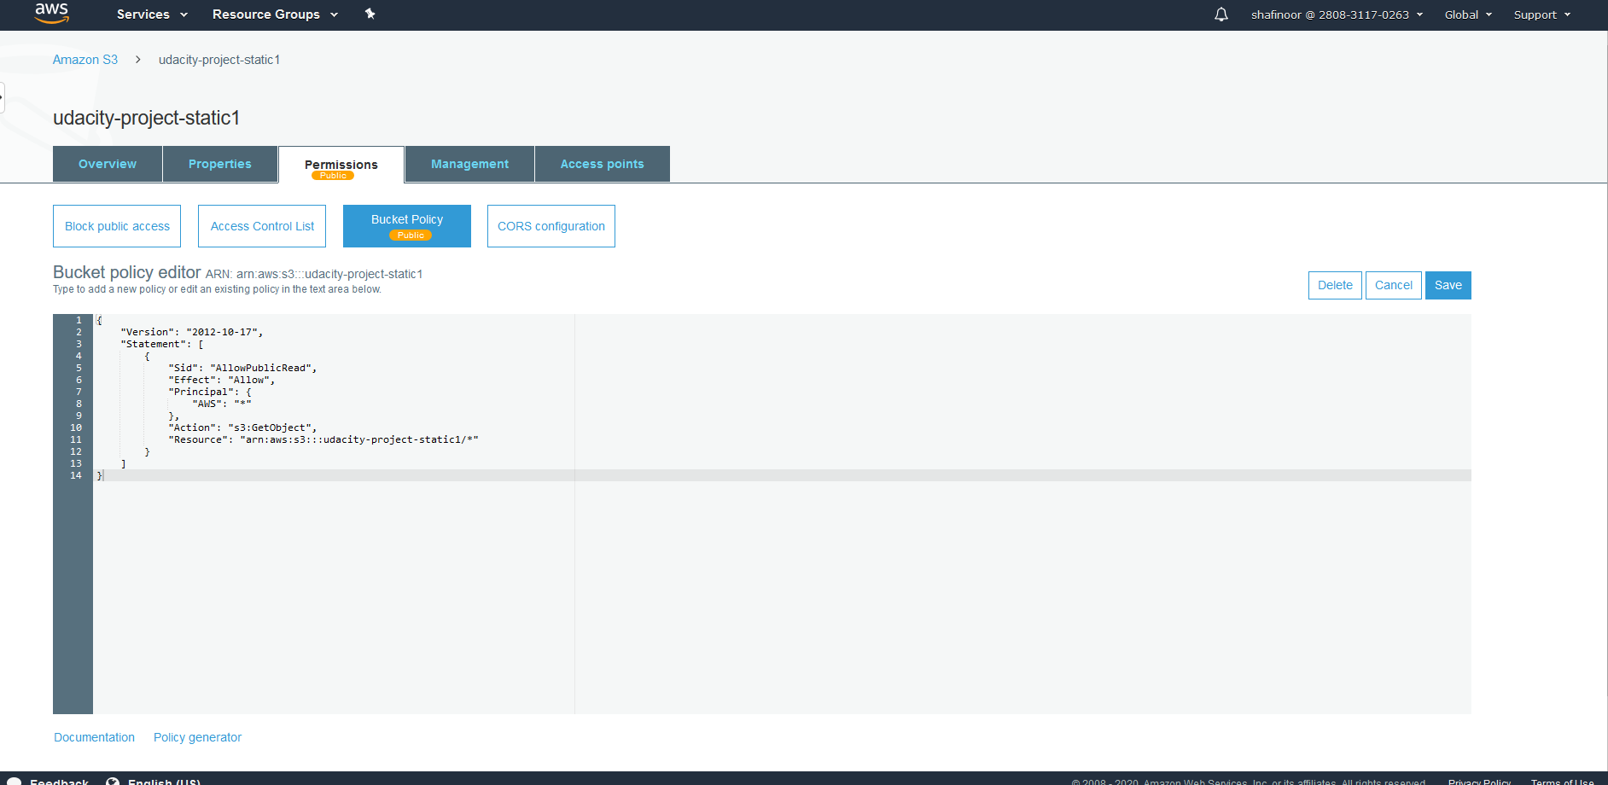

All the website files uploaded to the newly created S3 bucket:

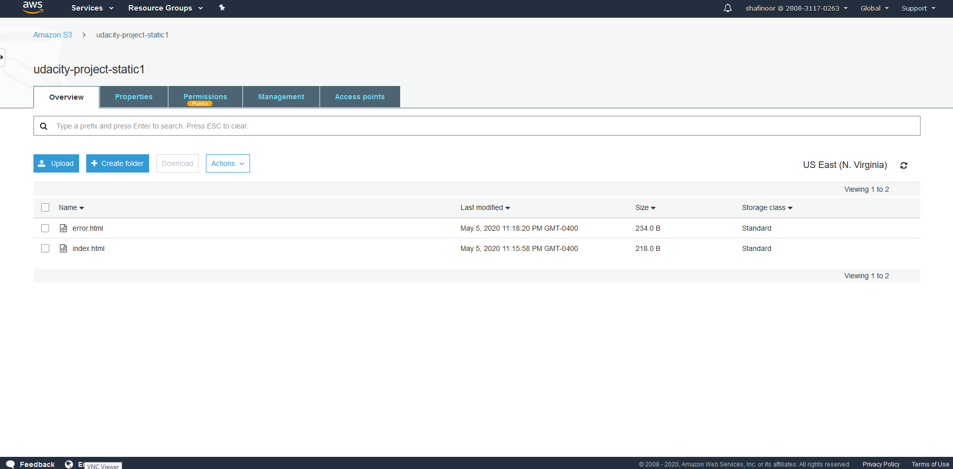

CloudFront has been configured to retrieve and distribute website files:

